EWSD
SYSTEM OVERVIEW

1. INTRODUCTION

2. SYSTEM FEATURES

3. SYSTEM ARCHITECTURE

3.1 DLU

3.2 LINE/TRUNK GROUP

3.3 SWITCHING NETWORK

3.4 COORDINATION AREA

  - COMMON CHANNEL SIGNALING CONTROL

4. SUBSCRIBER/ADMINISTRATION FACILITIES IN EWSD
EWSD - SYSTEM DESCRIPTION
1.0 INTRODUCTION
After years of being treated as a luxury, telecommunications has come into its own in the Eighth Plan. The Department of Telecommunication has announced ambitious plans for the addition of 7.5 million lines to the existing 5.8 million by the end of the 8th Plan (1992-97) as compared to only 3.2 million in 1982-92.
To bridge the gap between the supply and demand DoT invited a tender for 200,000 lines of digital switching equipment on Rupee payment. In the industrial policy of July 1991, Telecom equipment was delicensed and thrown open to foreign investments. Consequently, six new technologies were planned to be validated. These foreign suppliers set up their validation exchanges, each of 10,000 lines capacity (including two RSUs of 2K each), at different places, e.g. EWSD of Siemens (Germany) at Calcutta, AXE-10 of Ericsson (Sweden) at Madras, Fetex-150 of Fujitsu (Japan) at Bombay, OCB-283 of Alcatel (France) at Delhi etc.
Three new Digital Switching Systems, i.e., EWSD, AXE-10, Fetex-150, which got validated first, were inducted in the Indian Telecom, Network and three lakh lines were imported from these three suppliers. In addition 3.5 lakh lines were also imported on lease basis from these suppliers. Subsequently, four more switches, i.e., OCB-283 of Alcatel (France), 5 ESS of AT&T (USA), System-X of GPT (UK) and NEAX-61E of NEC (Japan) also got validated.
EWSD is one of the two technologies selected for TAX and is also the technology for Intelligent Network and Mobile Communication. This article gives a general introduction to the EWSD system, its features, architecture and facilities.
2.0 SYSTEM FEATURES
EWSD Digital Switching System has been designed and manufactured by M/s Siemens, Germany. The name is the abbreviated form of German equivalent of Electronic Switching System Digital (Electronische Wheler Systenic Digitale). EWSD switch can support maximum 2,50,000 subscribers or 60,000 incoming, outgoing or both way trunks, when working as a pure tandem exchange. It can carry 25,200 Erlang traffic and can withstand 1.4 million BHCA. It can work as local cum transit exchange and has CCS No.7, ISDN and IN capabilities.
3.0 SYSTEM ARCHITECTURE
The main hardware units of an EWSD switch are as under :
- Digital Line Unit (DLU) – functional unit on which subscriber lines are terminated.
- Line/Trunk Group (LTG) – Digital Trunks and DLUs are connected to LTGs.
The access function determined by the network environment are handled by DLUs and LTGs.
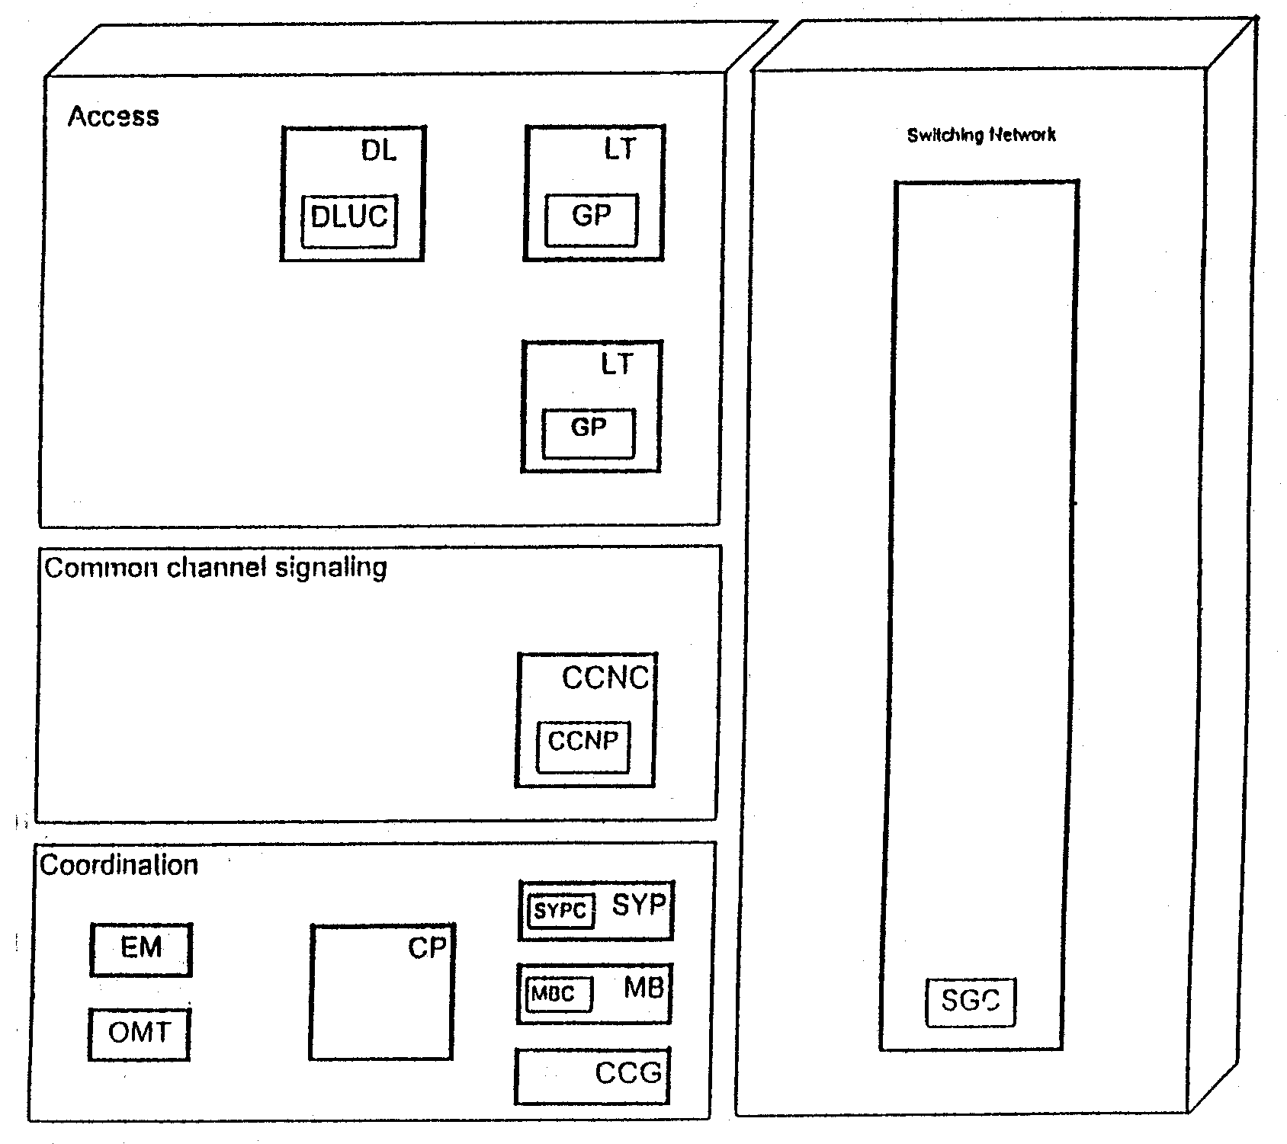
Fig.1
Distributed Controls in EWSD
- Switching Network (SN) – All the LTGs are connected to the SN which interconnects the line and trunks connected to the exchange in accordance with the call requirement of the subscribers. CCNC and CP are also connected to SN.
- Coordination Processor (CP) – It is used for system-wide coordination functions, such as, routing, zoning, etc. However, each subsystem in EWSD carry out practically all the tasks arising in their area independently.
- Common Channel Signalling Network Control (CCNC) Unit – This unit functions as the Message Transfer Part (MTP) of CCS-7. The User Part (UP) is incorporated in the respective LTGs.
Block diagram of EWSD is given in Fig.1. It also shows that the most important controls are distributed throughout the system. This distributed control reduces the coordination overheads and the necessity of communication between the processors. It results in high dynamic performance standard.
For inter-processor communications, 64 kbps semipermanent connections are set through SN. This avoids the necessity for a separate interprocessor network.
3.1 Digital Line Unit (DLU)
Analog or Digital (ISDN) subscribers or PBX lines are terminated on DLU (Fig.4). DLUs can be used locally within the exchange or remotely as remote switch unit, in the vicinity of the groups of subscribers.
DLUs are connected to EWSD sub-systems via a uniform interface standardized by CCITT, i.e., Primary Digital Carrier (PDC) to facilitate local or remote installation. A subset of CCS#7 is used for CCS on the PDCs.
One DLU is connected to two different LTGs for the reasons of security (Fig.2). A local DLU is connected to two LTGs via two 4 Mbps (64 TSs) links, each towards a different LTG. In case of remote DLUs maximum 4 PDCs of 2 Mbps (32 TSs) are used per DLU; two towards each LTG. Hence, total 124 channels are available between a DLU and the two LTGs, out of which 120 channels are used for user information (speech or data) and signalling information is carried in TS16 of PDC0 and PDC2.
Within the DLU, the analog subscribers are terminated on SLMA (Subscriber Line Module Analog) cards (module). Similarly Digital (ISDN) subscribers are terminated on the SLMD modules. Each module can support 8 subscribers, hence has 8 SLCAs (Subscribers Line Circuit Analog) and one SLMCP( Subscribers Line Module Circuit Processor).
One DLU can carry a traffic of 100 Erlangs. A standard rack of DLU (local or remote) can accommodate one DLU of 944 subscribers or two DLUs of 432 subscribers each. Smaller racks (shelter) are also available for remote DLUs in which lesser number of subscribers can be equipped.

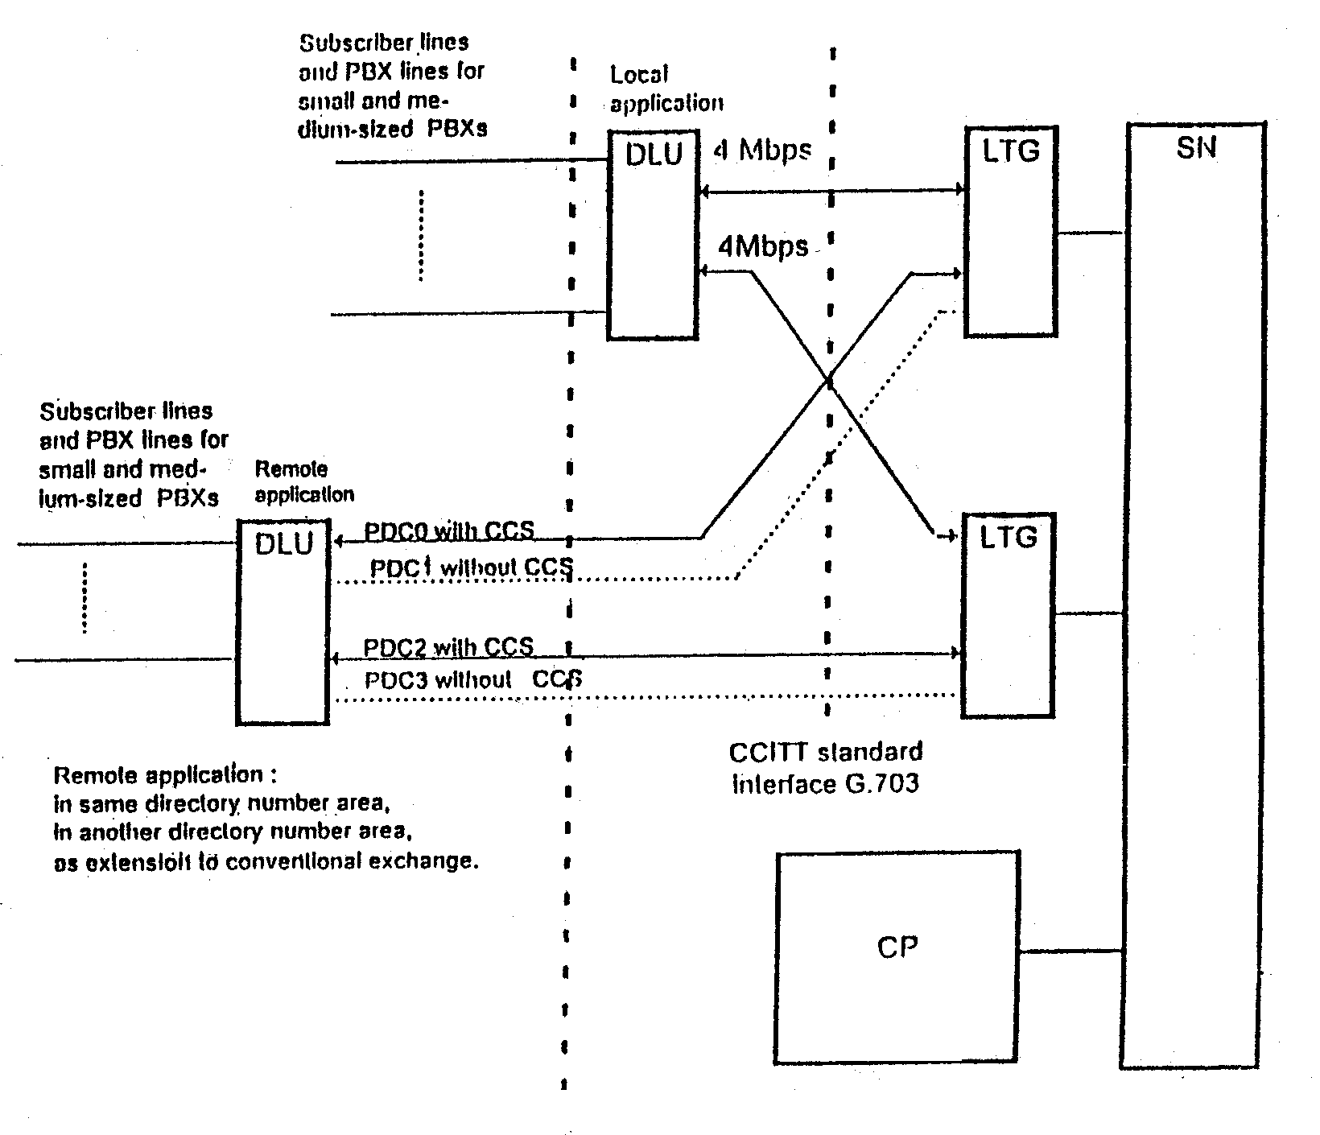
Fig.2
Applications for and connection of Digital Line Unit
In case the link between a remote DLU and the main exchange is broken, the subscribers connected to the remote DLU can still dial each other but metering will not be possible in this case. For emergency service DLU-controller (DLUC) always contain up-to-date subscribers data. Stand Alone Service Controller card (SASC) is provided in each R-DLU for switching calls in such cases. This card is also used for interconnecting a number of remotely situated DLUs (maximum 6), in a cluster, called a Remote Control Unit (RCU), so that subscribers connected to these remote DLUs can also talk to each other in case the link of more than one DLU to the main exchange is broken. An EMSP module (Emergency Service equipment for Push-button subscribers) is used to make internal calls by DTMF subscribers when the remote DLU link is broken.
All DLUs are provided with a Test Unit (TU) for performing tests and measurements on SLCAs, subscribers lines and telephones. An ALEX (Alarm External) module is used for forwarding external alarms, i.e., fire, temperature, etc. to System Control Panel (SYP). Number of SLMAs are accordingly reduced to accommodate these modules. The main components of a DLU as shown in Fig.3 are
- SLMAs and/or SLMDs.
- Two Digital Interface Units Digital (DIUD) for connections of the PDCs.
- Two DLU Controls (DLUC).
- Two 4 Mbps networks for the transmission of user information between SLMs and the DIUDs.
- Two control networks for the transmission of control information between SLMs and DLUCs.
- TU, EMSP, ALEX modules.

PDCO

PDC1
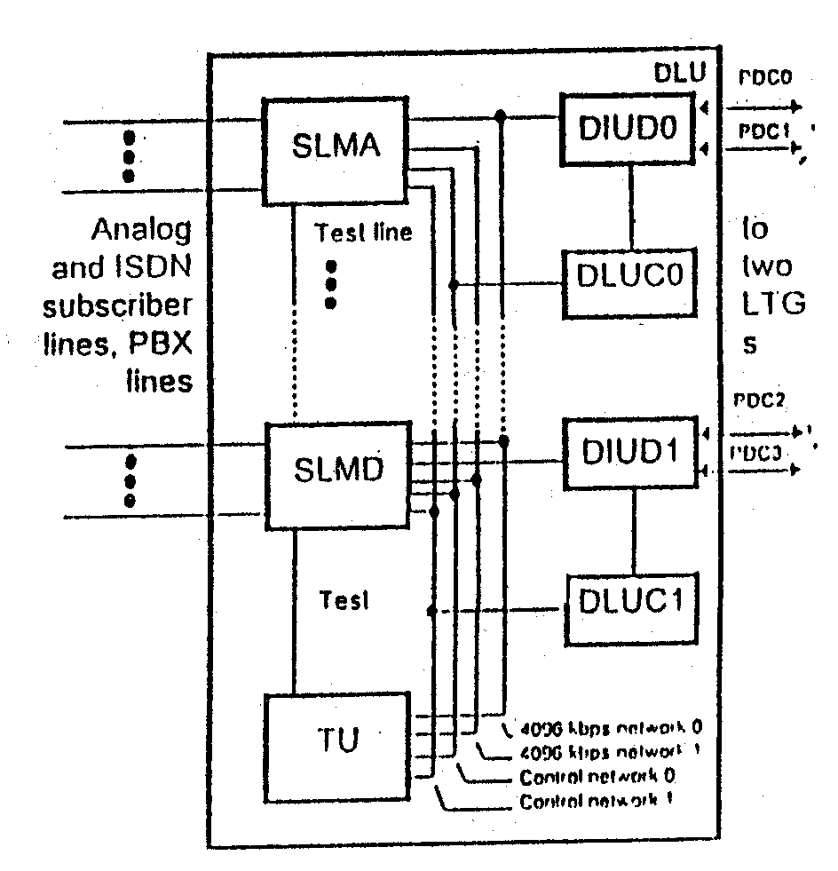
Fig.3

Test
Main Components of a DLU
3.2 Line/Trunk Groups
The line/trunk groups (LTG) form the interface between the digital environment of an EWSD exchange and the switching network (SN). The LTGs are connected in any of the following ways (Fig.4).
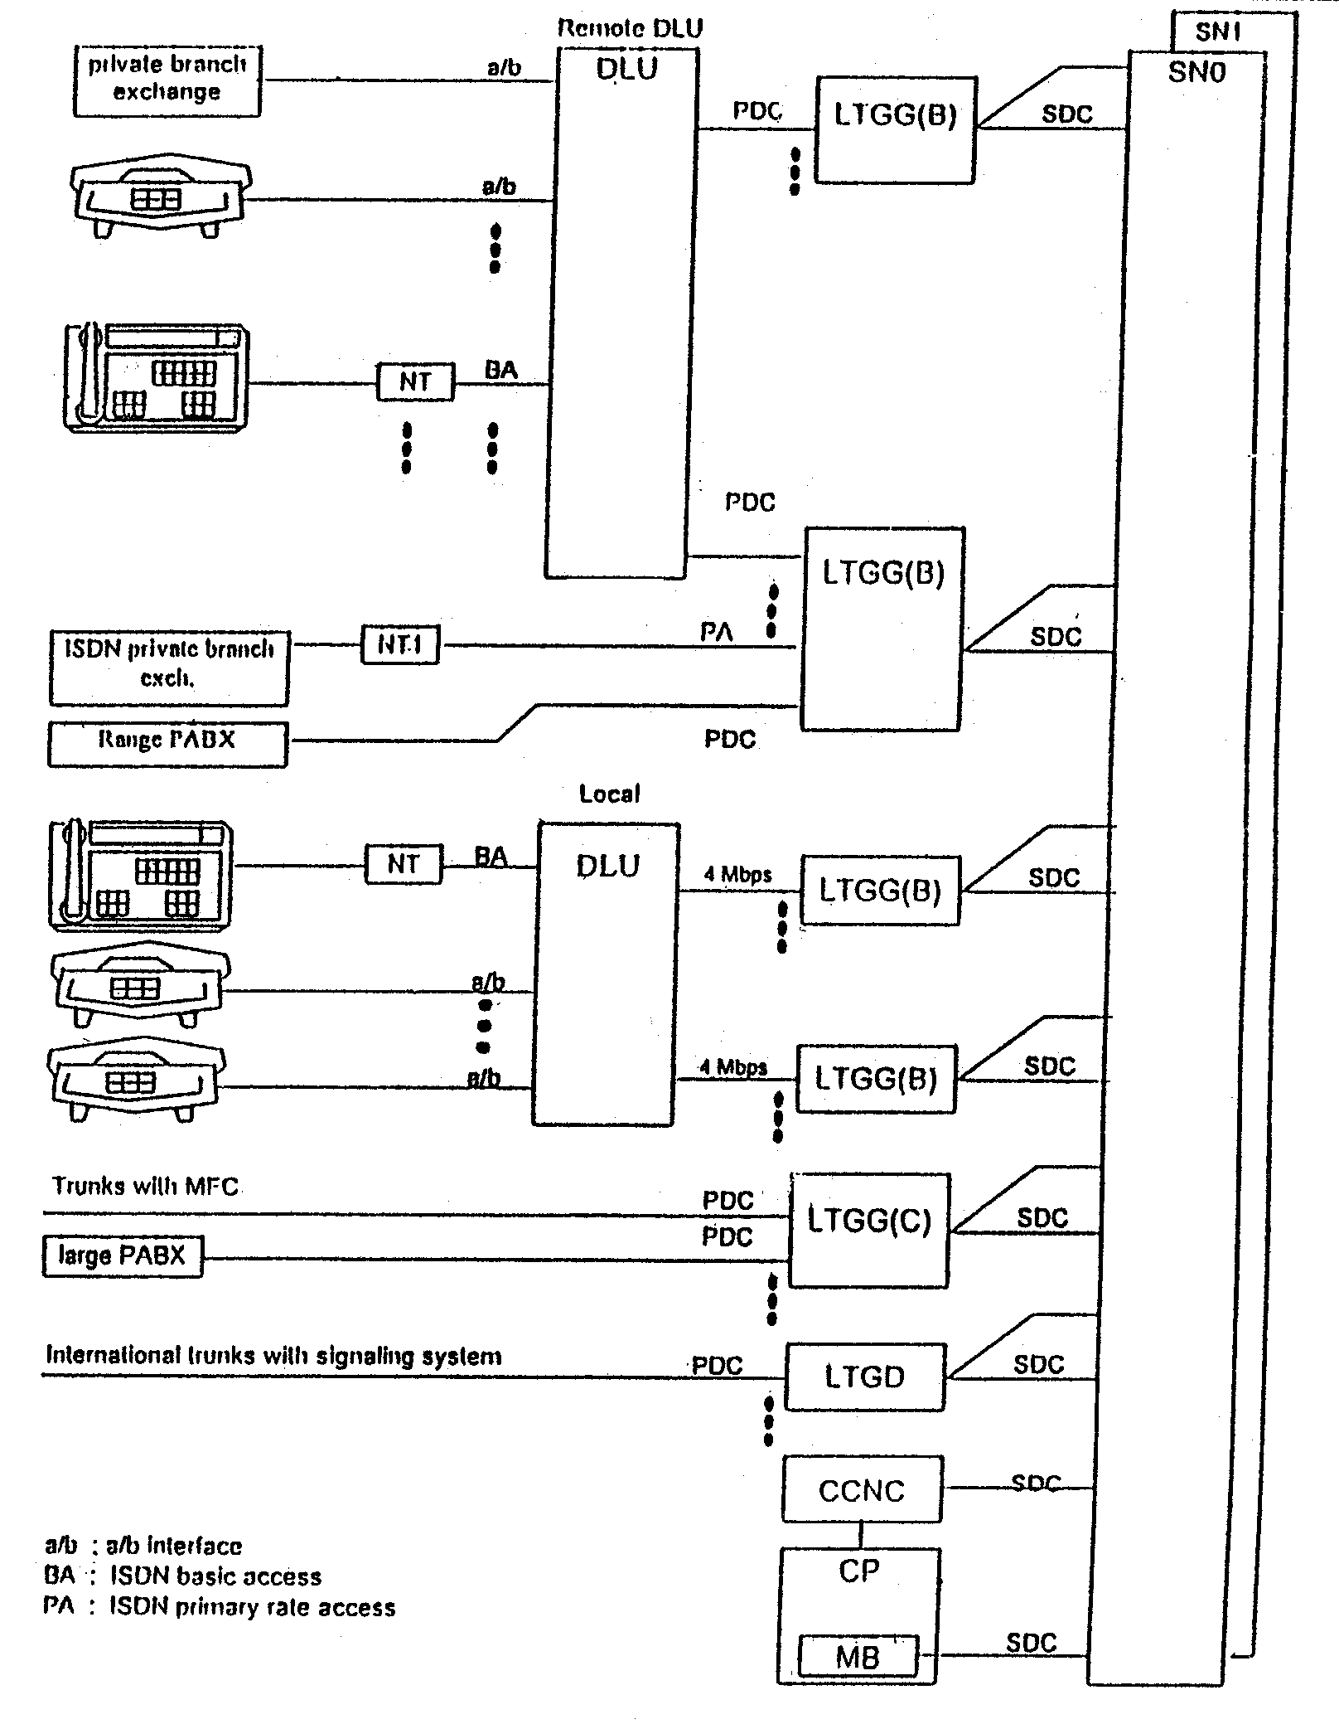
Fig.4
Line/Trunk Groups
- Via 2/4 Mb/s PDCs with remote/local DLUs to which analogue or ISDN subscribers are connected.
- Via 2 Mbps digital access lines to other digital exchanges in the network, or via Signal Converter-Multiplexer (SC-MUX) to analog trunks from analog exchanges in the network. SC-MUX do not form the part of the EWSD exchange equipment.
- Via Primary rate Access lines to ISDN PBXs (ISDN subscribers with PA).
Functions
The primary functions of the LTG are as follows :
- Call processing functions, i.e., receiving and analyzing line and register signals, injecting audible tones, switching user channels from and to the switching network, etc.
- Safeguarding functions, i.e., detecting errors in the LTG and on transmission paths within the LTG, analyzing the extent of errors and initiating counter measures such as disabling channels or lines, etc.
- Operation and maintenance functions, acquiring traffic data, carrying out quality-of-service measurements, etc.
The LTGs can work with all standard signalling systems (e.g. CCITT No. 5, R2, No.7). Echo suppressors can be incorporated in the LTGs for the connection of long-haul circuits (e.g., via satellite).
Although the subscriber lines and trunks employ different signalling systems, the LTGs present signalling-independent interface to the switching network. This facilitates the following :
- flexible introduction of additional or modified signalling procedures,
- a signalling-independent software system in the CP for all applications.
The bit rate on all highways linking the line/trunk groups and the switching network is 8192 kbps (8 Mbps). Each 8 Mbps highway contains 128 channels at 64 kpbs each. Each LTG is connected to both planes of the duplicated switching network.
The functional units of the line/trunk gorup as shown in Fig.5 are :

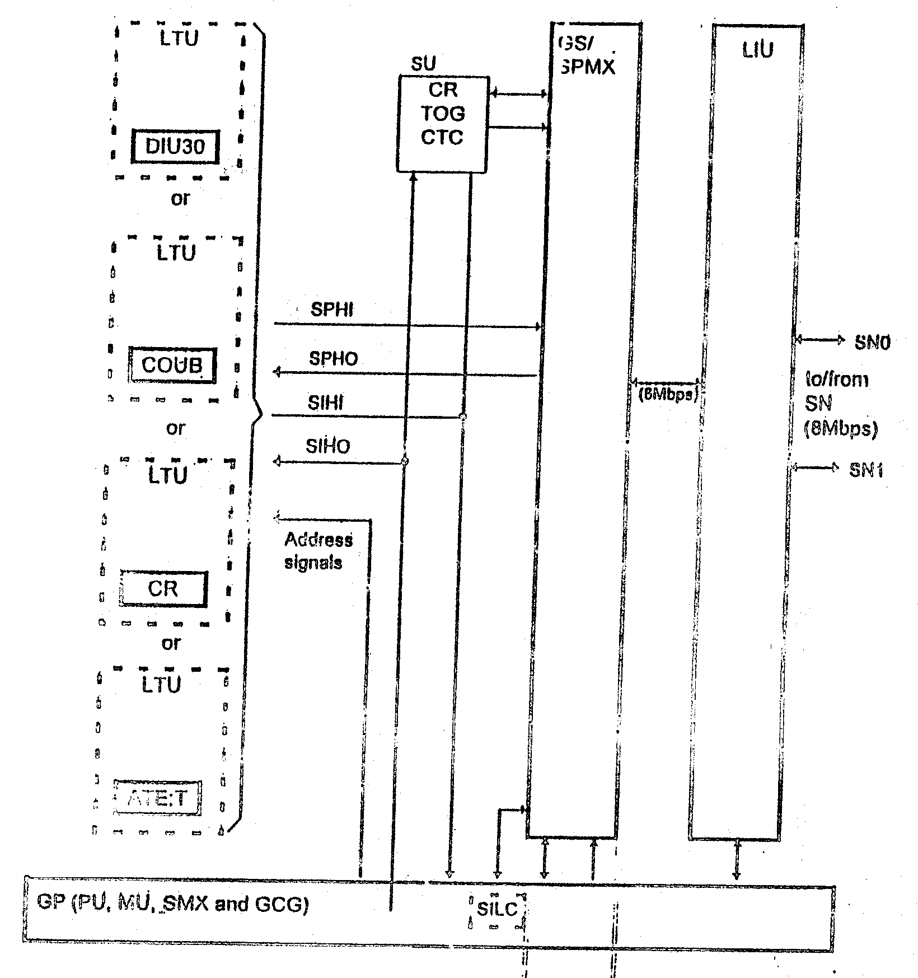
Fig.5
Functional units of the LTG
- Line/Trunk Unit (LTU) is a logical unit that comprises 8 number of different functional units, i.e.
- Digital Interface Unit (DIU30) for connection of 2 Mbps digital trunks and either DLU or PA. One LTG can comprise four DIU30.
- Code Receivers (CR) are multi-frequency code receivers for trunks or DTMF subscribers.
- Conference Unit, module B (COUB) for conference calls.
- Automatic Text Equipment for Trunks (ATE:T) checks trunks and Tone Generators (TOG) during routine tests.
- Signalling Unit (SU) comprises Tone Generator (TOG) for audible tones, Code Receivers (CR) for MFC signalling and push-button dialing and Receiver Module for Continuity Check (RM-CTC), etc.
- Group Switch (GS) or Speech Multiplexer (SPMX) are used for DLUs or trunks respectively. These are non-blocking time stage switch controlled by the GP.
- Link Interface Unit (LIU) connects LTG to SN via two parallel 8 Mbps SDCs.
- Group Processor (GP) controls the functional units of the LTG. The received signals from LTU, SU, GS/SPMX and LIU are processed with the help of GP software.
In LTGG, GS and LIU have been combined into GSL module. Only LTGGs have been supplied to India. One LTG rack can accommodate 40 PCMs in five LTGG frames, each containing two LTGGs.
3.3 Switching Network
Different peripheral units of EWSD, i.e., LTGs, CCNC, MB are connected to the Switching Network (SN) via 8192 kbps highways called SDCs (Secondary Digital Carriers), which have 128 channels each. The SN consists of several duplicated Time Stage Groups (TSG) and Space Stage Groups (SSG) (Fig.6) housed in separate racks. Connection paths through the TSGs and SSGs are switched by the Switch Group Controls (SGC) provided in each TSG and SSU, in accordance with the switching information from the coordination processor (CP). The SGCs also independently generate the setting data and set the message channels for exchange of data between the distributed controls.
The switching network is always duplicated (planes 0 and 1). Each connection is switched simultaneously through both planes, so that a standby connection is always immediately available in the event of a failure.
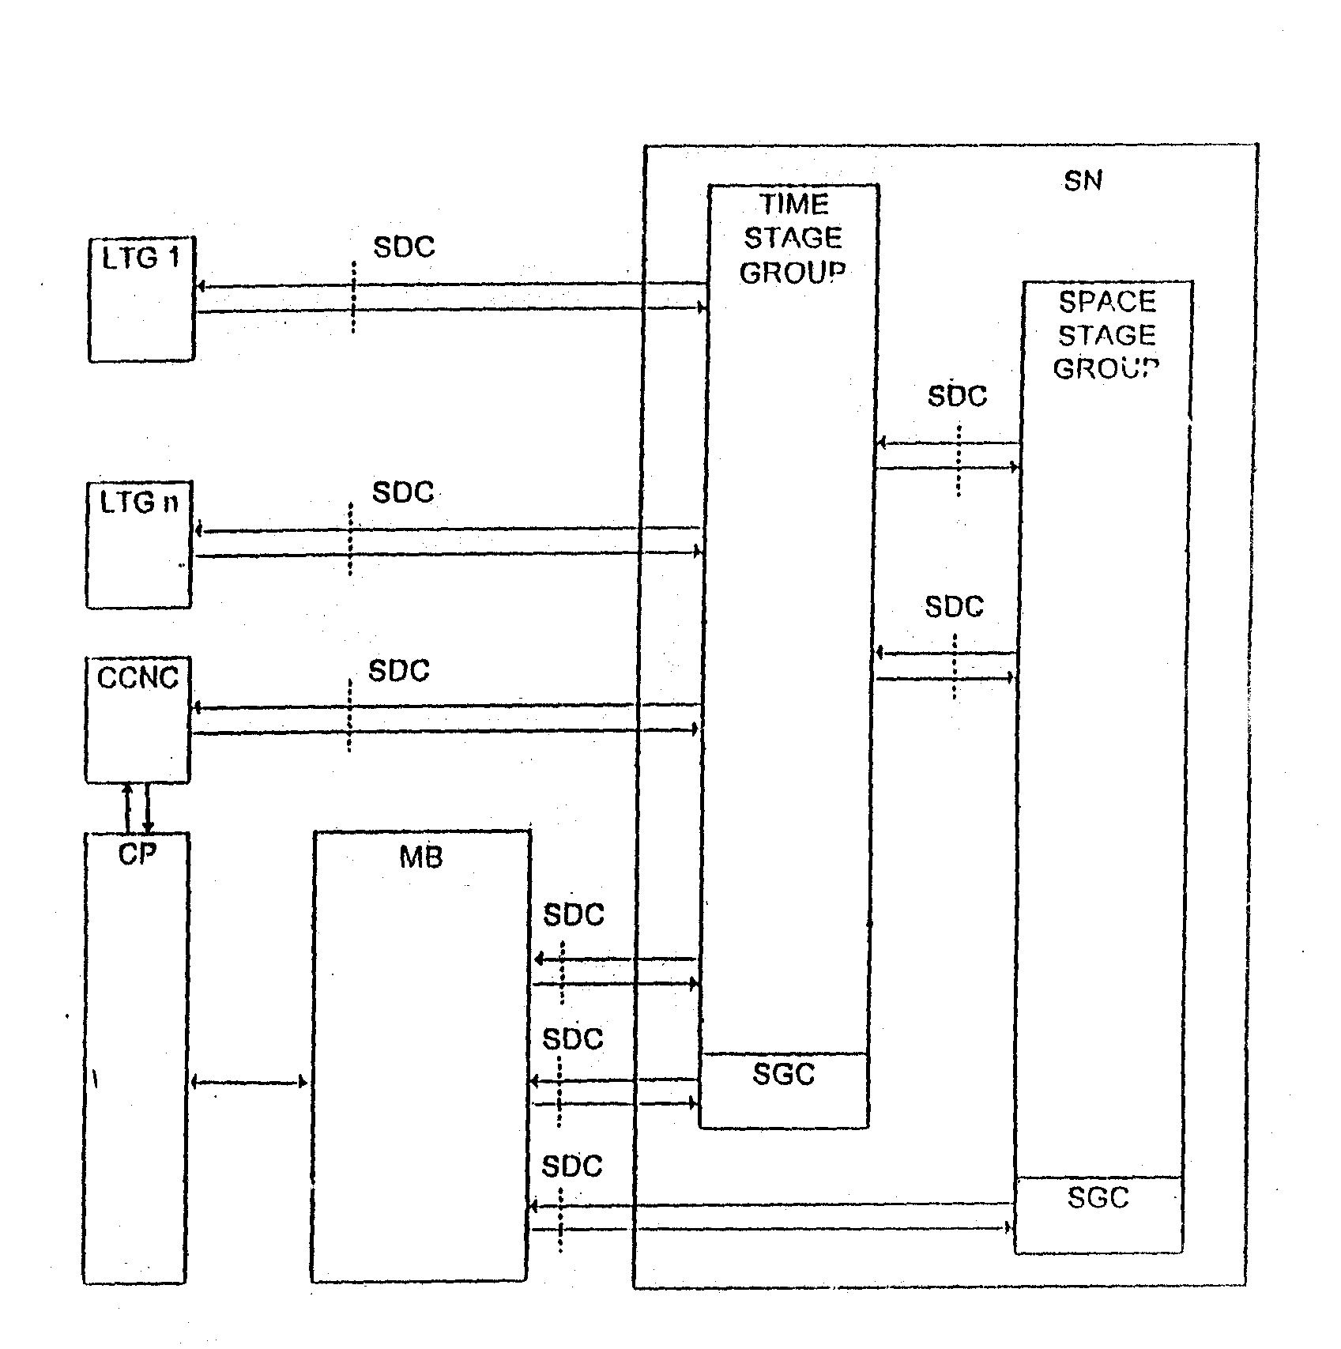
Each TSG can accommodate 63 SDCs from LTGs and one SDC to MB. One SDC is extended from SGC of each TSG and SSG towards MB. Thus one TSG can handle upto 63 LTGs. The switching network can be expanded in small stages by adding plug-in modules and cables and if necessary by assigning extra racks. Optimized switching network configurations are available in a range of sizes. The smallest duplicated SN:63 LTG configuration which can handle 30,000 subscriber lines or 7,500 trunks when fully equipped is installed in a single rack and can handle 7,500 erlangs traffic. In its maximum configuration, the EWSD switching network has 8 TSGs and 4 SSGs (in 12 Racks) to connect 504 LTGs and has a traffic handling capacity of 25,200 erlangs. SNs for 126 LTGs and 252 LTGs are also available which can handle 6300 and 12600 erlangs traffic respectively.
Fig.6
Switching Network
The SN supplied in first 110K order contains only seven different types of module and each TSG and SSG is accommodated in a separate full rack. In the subsequent supplies SN(B) has been supplied which has only 5 types of modules and each TSG and SSG is accommodated in only two shelves of the respective racks. Remaining four shelves accommodate LTGs.
3.4 Coordination Area
3.4.1 Coordination Processor
The coordination processor (CP) handles the data base as well as configuration and coordination functions, e.g. :
- Storage and administration of all programs, exchange and subscriber data,
- Processing of received informations for routing, path selection, zoning, charges,
- Communication with operation and maintenance centers,
- Supervision of all subsystems, receipt of error messages, analysis of supervisory result messages, alarm treatment, error messages, alarm treatment, error detection, error location and error neutralization and configuration functions.
- Handling of the man-machine interface.
CP 113 is used in medium-sized to very large exchanges. The CP113 is multiprocessor and can be expanded in stages. It has a maximum call handling capacity of over 1,000,000 BHCA. In the CP113 as shown in Fig.7, two or more identical processors operate in parallel with load sharing. The rated load of n processors is distributed among n+1 processors. This means that if one processor fails, operation can continue without restriction (redundancy mode with n+1 processors).
The basic functional units of CP 113 are as follows :
- Base Processor (BAP) – for operation and maintenance and call processing.
- Common Memory (CM) – 64 to 1024 MB in 4 memory banks consisting of 4 MB DRAM chips.
- Input/Output Controller (IOC) – 2 to 4 IOCs coordinate and supervise accessing of CMY by IOPs.
- Input/Output Processors (IOP) – Various types of IOPs are used to connect the CP113 to the other subsystems and functional units of the exchange as well as to the external mass storage devices (EM i.e., MDD, MTD), the two O&M terminals (OMT), to OMC via data lines, etc. (Fig.8). Maximum 16 IOPs can be connected to one IOC.
The other functional units of CP 113 are call processors (CAP) which deal only with call processing functions. Hardware wise they are similar to BAPs and form a redundant pool together with BAPs.
3.4.2 Other Units Assigned to CP (Figure 1) : are
- Message Buffer (MB) : for coordinating internal message traffice between the CP, the SN, the LTGs and the CCNC in an exchange.

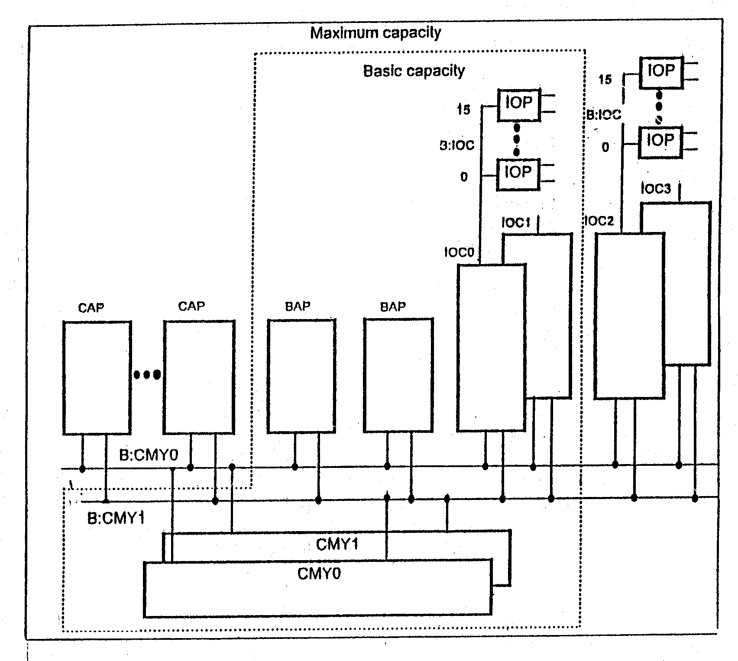

Fig. 7
Structure of CP 113
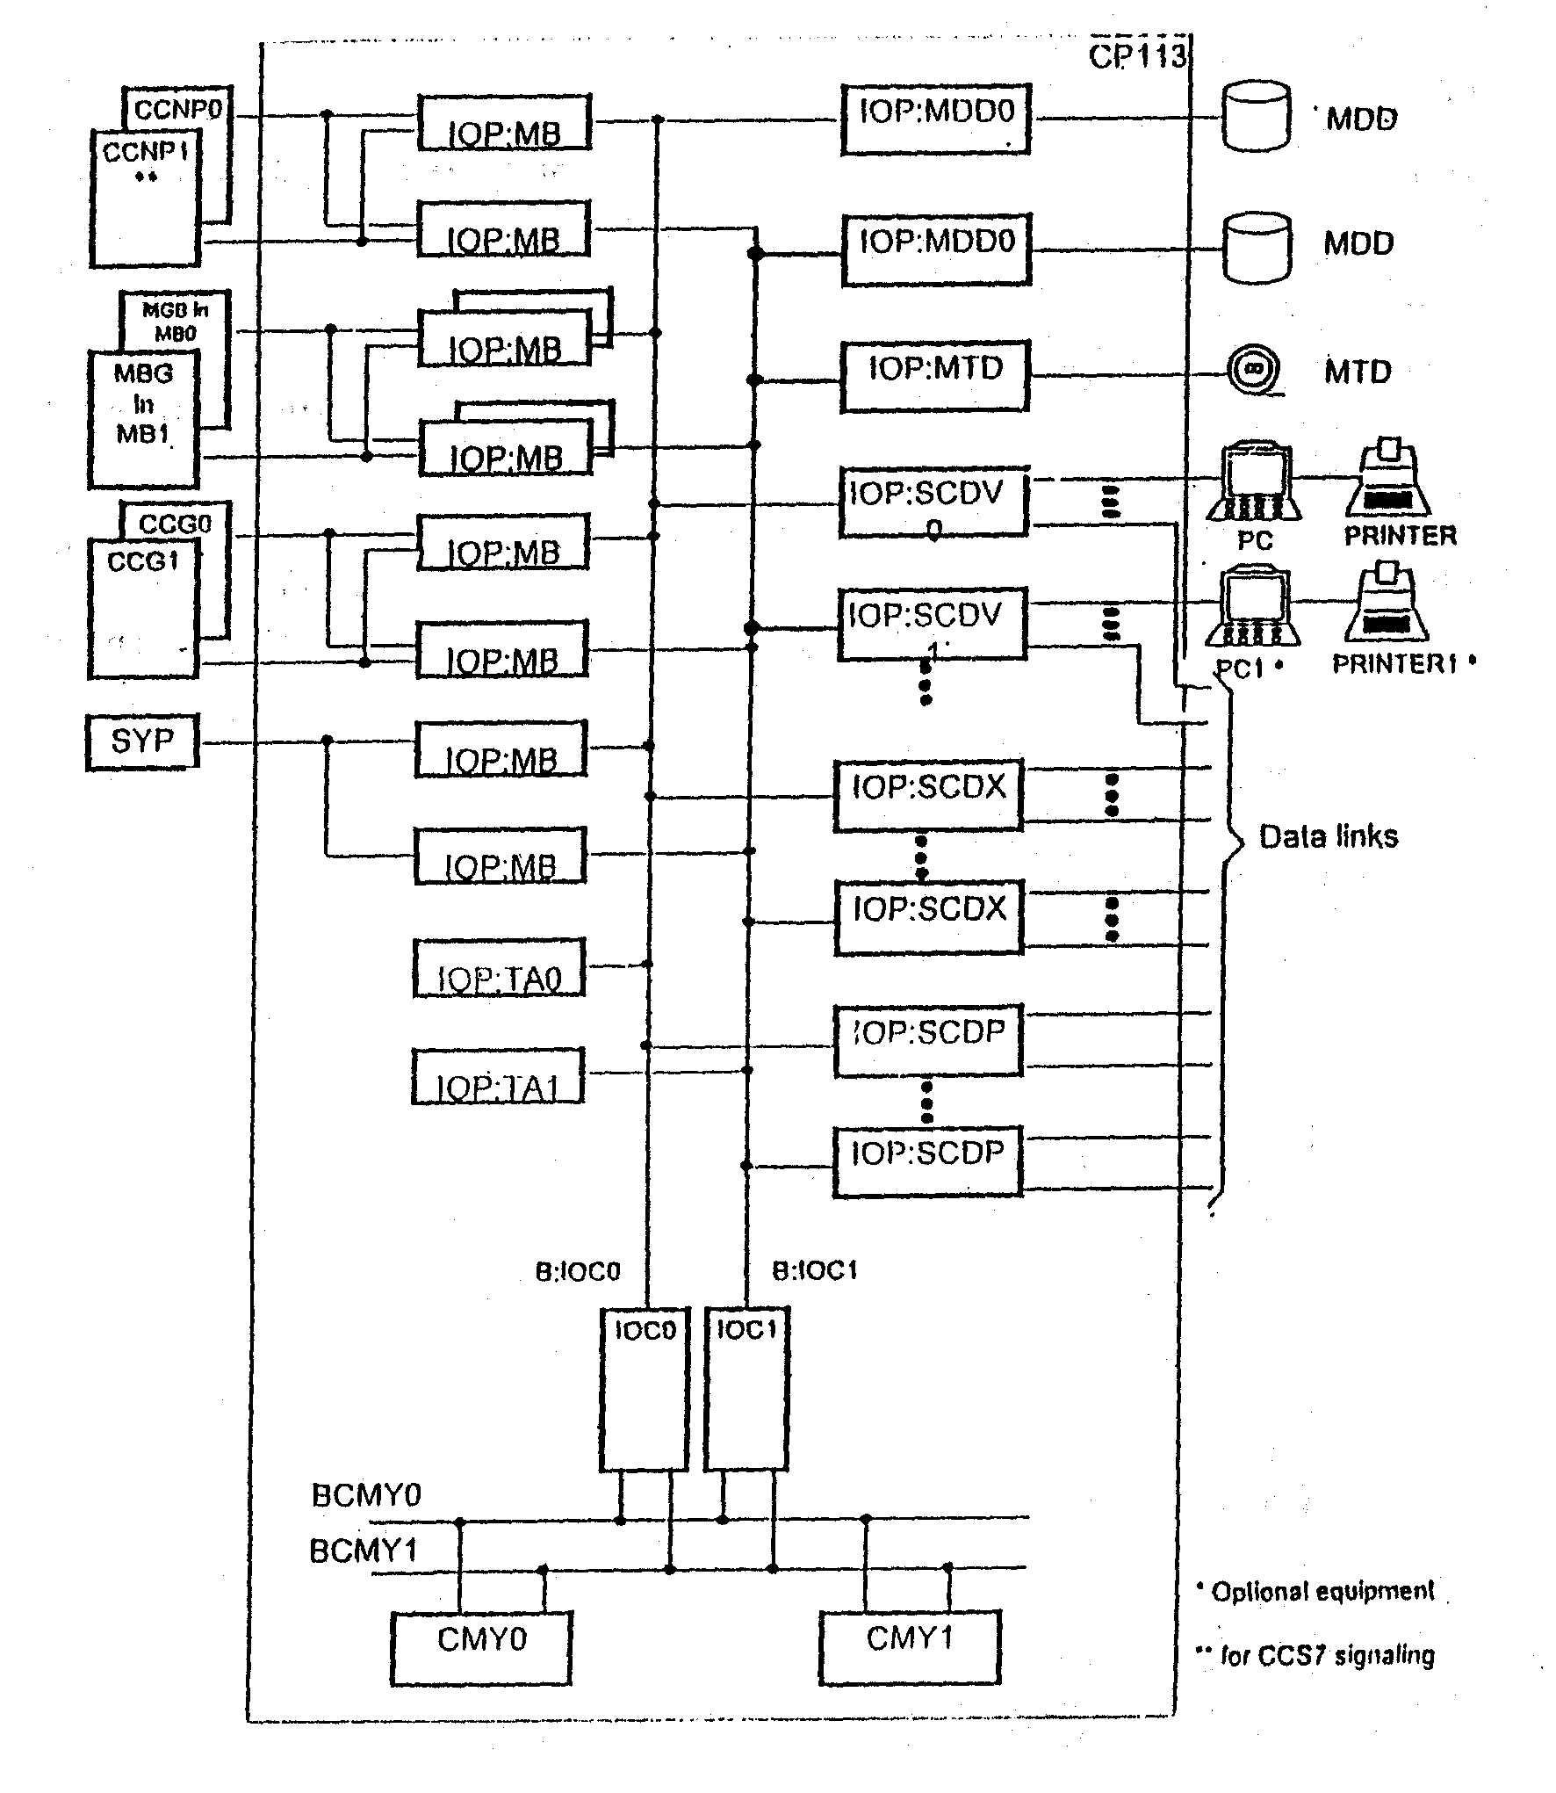

Fig. 8
Structure of Input/Output System with two IOCs.
- Central Clock Generator (CCG) : for the synchronization of the exchange and, where necessary, the network. The CCG is extremely accurate (10⁻⁹). It can, however, be synchronized even more accurately by an external master clock (10⁻¹¹).
MBs and CCG are equipped in two racks in maximum configuration.
- System Panel Display (SYPD) : to display system internal alarms and the CP load. It thus provides a continuous overview of the state of the system. The SYP also displays external alarms such as fire and air-conditioning system failure for example, it is installed in the Equipment Room or in the Exploitation Room.
- Operation and Maintenance Terminals : for Input/Output. Two OMTs are provided for O&M functions.
- External memory (EM) : for
- Programs and data that do not always have to be resident in the CP.
- An image of all resident programs and data for automatic recovery.
- Call charges and traffic measurement data.
To ensure that these programs and data are safeguarded under all circumstances, the EM is duplicated. It consists of two magnetic disk devices (MDD), each of 780 MB capacity. The EM also has a magnetic tape device (MTD), for input and output. These units are mounted in a separate device rack (DEVD).
3.5. Common Channel Signalling Network Control
The CCITT – standardized signalling system no. 7 (CCS7) is one of the systems that is used for interexchange signalling in EWSD. To promote flexibility in the use of this system, a distinction is made between a message transfer part (MTP) and the user parts (UP). The user parts vary according to the specific application (e.g. TUP : telephone user part, ISDN-UP : ISDN user part, MUP : mobile user part). The common MTP functions in an EWSD exchange are handled by the common channel signalling network control (CCNC) The UP is incorporated in the software of the relevant LTG.
A maximum of 254 common signalling channels can be connected to the CCNC via either digital or analog links. The digital links are extended from the LTGs over both planes of the duplicated switching network and multiplexers to the CCNC. The CCNC is connected to the switching network via two 8 mbps highways (SDCs). Between the CCNC and each switching network plane, 254 channels for each direction of transmission are available (254 channel pairs). The channels carry signalling data via both switching network planes to and from the LTGs at a speed of 64 kbps. Analog signalling links are linked to the CCNC via modems.
For reasons of reliability the CCNC has a duplicated processor (CCNP) which is connected to the CP by means of similarly duplicated bus system. The CCNC consists of (Figure 9) :
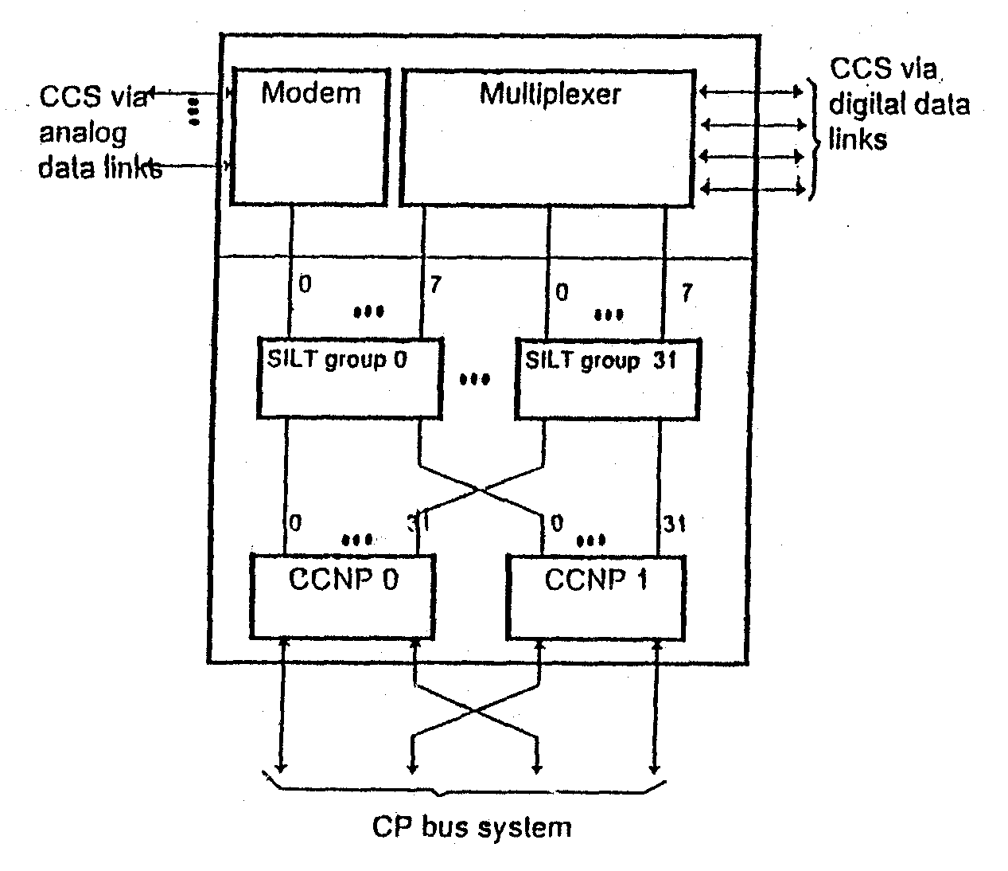
Fig. 9
Common Channel Signalling Network Control

- Upto 32 signalling link terminal (SILT) groups, each with 8 signalling links, and
- One duplicated common channel signalling network processor (CCNP).
The functions of the CCNC depend on its position in a signalling link. In the originating or destination exchange in associated signalling, it operates as signalling point (SP) and in transit exchange in quasi-associated signalling, it operates as a signalling transfer point (STP).
The CCNC, equipped in one rack can handle upto 48 signalling links. Equipments handling upto 96 signalling links can be equipped in additional racks.
Subscriber/Administration Facilities in EWSD
- Rapid call set up :
- Abbreviated Dialing
- Hotline Immediate
- Hotline with Time Out.
- Call Restriction Services :
- O/G Restrictions
- Administration Controlled
- Subs controlled
- I/C Barring
- Absent Subscriber Services :
- Immediate diversion
- Diversion on no reply
- to operator
- to a number
- to announcement
- Call Completion Services :
- Diversion on busy
- Call waiting
- Call priority (originating & terminating)

- Multiparty services :
- Conference call
- Tele-meeting

- Alarm call booking :
- Casual
- Regular (number of consecutive days).

- Services to PBX :
- Direct dialing in (for different PBX capacities).
- Line hunting

- Miscellaneous services :
- Malicious call identification
- All calls
- Special subscriber signal

- Call charge services :
- Separate counters for Local Call charges, STD/ISD call charges, Number of calls, Service activation charges and Service usage charges.
- Transmission of meter pulses.
- Preventive meter observation (adjustable threshold).
SYSTEM DATA

Call-handling capacity | No. of Subscriber lines | max. 250000
 | No. of Trunks | max. 60000
 | Switchable traffic | max. 25200 E
Supply voltage | -48V nominal direct voltage
Clock accuracy | Maximum relative frequency deviation :  plesiochronous 10⁻⁹; synchronous 10⁻¹¹
Signalling systems | All conventional signalling systems,  e.g. CCITT R2, No. 5, No. 7
Analog subscriber line and trunk accesses | Various loop and shunt resistance possible. Push-button dialing, Multi-freq. signalling to CCITT recommendation Q.23, Rotary dialing : 5 to 22 pulse/s
ISDN accesses | Basic access 160 kpbs (2B + D+sync.)  B = 64 kpbs,  D = 16 kbps
 | Primary rate access 2048 kpbs (30B + D + sync.)
Digital trunk accesses | 2048 kbps
Traffic routing | Per destination max. 7 high-usage routes and one final route. Sequential or random selection of idle trunk of a trunk group. Number of trunk groups per exchange.  Max. 1000 incoming and  Max. 1000 outgoing and  Max. 1000 bothway
Call charge registration | Periodic pulse metering,  AMA Automatic Message Accounting or Detailed Billing (CAMA, LAMA)  IARSTAT (Inter Administration Revenue Accounting and Statistics).  Max. 127 zones  Max. 6 tariffs per zone  Tariff switchover possible in 15-minute timing intervals.  Transmission of communication data to computer centre (output on tape also possible).
Space requirements | Example : Exchange for 24000 lines  units, approx. 100 m²
Environmental conditions | Ambient temperature  Relative humidity | 5ºC to 40ºC  10% to 80%

ABBREVIATIONS

ALEX | External Alarm module | M: …. | Module for ….
APS | Application Program | MB | Message Buffer
ATE:T | Automatic Test Equipment for Trunks | MDD | Magnetic Disk Drive
B :- | Bus for … | MTA | Metallic Test Access
BA | Bus Arbiter | MTD | Magnetic Tape Drive
BAP | Base Processor | MTP | Message Transfer Part
CAP | Call Processor | MU | Memory Unit
CCG | Central Clock Generator | OMT | O&M Terminal
CCNC | Common Channel Signalling Network Control | PDC | Primary Digital Carrier
CCNP | Common Channel Network Processor | R : …. | Rack for …
CMY | Common Memory | RCU | Remote Control Unit
COUB | Conference Unit, Module B | S : …. | Shell for ….
CP | Coordination Processor | SASC | Stand Alone Service Controller
CR | Code Receiver | SC-MUX | Signal Converter Multiplexer
CTC | Continuity Check | SGC | Switch Group Control
DEVD | Device Rack | SILT | Signalling Link Terminal
DIU30 | Digital Interface Unit for 2 Mbps digital trunks | SLCA/D | Subscriber Line Circuit Analog/Digital
DIUD | Digital Interface Unit for DLU | SLMA/D | Subscriber Line Module Analog/Digital
DLU | Digital Line Unit | SLMCP | Processor for SLM for DLU
DLUC | Control for DLU | SN | Switching Network
EM | External Memory | SPMX | Speech Multiplexer
EMSP | Emergency Service equipment for Push-button subscribers | SSG | Switch Stage Group
GP | Group Processor | SU | Signalling Unit
GS | Group Switch | SYPD | System Panel Display
GLS | GS & LIU module | TA | Terminal Adapter
IOC | Input/Output Control | TOG | Tone Generator
IOP | Input/Output Processor | TSG | Time Stage Group
ISDN | Integrated Services Digital Network | TU | Test Unit
LDID | Local DLU Interface Unit module D | UP | User Part
LIU | Link Interface Unit between LTG & SN
LTG | Line/Trunk Group

Annexure III
Details of EWSD Exchanges Commissioned/Planned in the DoT Network

 |  | First PO  110 K | Lease Order  140 K | 1700K PO  290 K | TAX
Punjab | Amritsar  Jalandhar |  | 20 K  10 K | 10 K
Haryana | Faridabad  Gurgaon |  | 10 K | 35 K
Rajasthan | Jaipur  Udaipur | 10 K | 23 K  06 K | 70 K
UP | Agra  Noida  Kanpur  Meerut  Ghaziabad  Allahabad  Lucknow | 10 K  10 K  10 K | 10 K | 10 K  10 K  10 K
MP | Indore  Raipur | 10 K | 10 K | 35 K | 10 K  6 K
Bihar | Ranchi | 10 K | - | -
West Bengal | Calcutta  Validation Exch. | 10 K | - | 60 K
AP | Hyderabad  Vijaywada  Vizag | 40 K | 10 K  10 K
Gujarat | Ahmedabad  Surat |  | 20 K |  | 25 K  11 K
Maharashtra | Nagpur  Bombay |  | 10 K | 20 K | 30 K
Tamil Nadu | Trichy  Salem  Madurai |  |  | 10 K  10 K  10 K | 10 K
TOTAL |  | 110 K | 139 K | 290 K | 92 K

Common Channel Signalling #7 in EWSD
1. Review of CCS#7
Today, most transmission between telephone exchanges is digital. But signalling is still based on signalling systems developed for analogue exchanges. In a telecommunication network, signalling can be defined as the exchange of information specifically concerned with both the establishment and control of connections, and with management. In analogue communication networks, channel-associated signalling systems have so far been used to carry the control information, but the systems do not meet requirements in digital, processor-controlled communication network. With the advance in computer technology, the introduction of up-to-date signalling systems is now possible. Such signalling systems should be based on data communication techniques and should be able to transfer other information apart from signalling. Signalling system #7 has been developed by CCITT to meet these demands. Because this system uses a single channel for all signalling between two exchanges, it is called common channel signalling.
This signalling protocol is a form of data communication in which all information is transmitted in labeled messages.
Because all information is transferred independently of the telephone channels, it is possible to transfer all kinds of informations via the signalling channel and to route the signalling in different ways through the system depending on the line conditions.
Signalling system #7 has been designed to provide different user groups with their own sets of messages. This makes it easy to implement new messages for one user group without affecting other user groups in the system.
CCS-7 is characterized by the following main features :
- internationally standardized (national variations possible).
- suitable for the national, international and intercontinental network level.
- suitable for various communication services such as telephony, text services, data services and other services.
- suitable for service-specific communication networks and for the integrated services digital network (ISDN).
- high performance and flexibility along with a future-oriented concept which will meet new requirements.
- high reliability for message transfer.
- processor-friendly structure of messages (signal units of multiples of 8 bits).
- signalling on separate signalling links; the bit rate of the circuits is, therefore, exclusively for communication.
- signalling links always available, even during existing calls.
- use of the signalling links for transferring user data also.
- used on various transmission media
- cable (copper, optical fibre)
- radio relay
- satellite (up to 2 satellite links)
- use of the transfer rate of 64 kbits/s typical in digital networks.
- used also for lower bit rates and for analogue signalling links if necessary
- automatic supervision and control of the signalling network.
Signalling system #7 user categories currently in use include telephone, data, mobile, ISDN and IN.

1.1 CCS#7 Levels
The CCS#7 is divided into two main parts so that it can be optimally adapted to the different requirements of the various services. These are the message transfer part (MTP0) and the user part (UP).
The MTP is identical for all user parts. It is an efficient means of transportation, which provides for reliable exchange of signals between the user parts at both ends of the signalling link. The UP allows for the different requirements of the various applications, e.g. telephone user part (TUP), data services user part (DUP), mobile user part (MUP), ISDN user part (ISUP), etc.
The entire structure of CCS#7 is divided into 4 levels on the lines of 7-layer OSI model of data communication. Levels 1, 2 and 3 together are called the Message Transfer Part (MTP) and level 4 represents the User Part.
Level 1 - Signalling Data Link : It defines the physical, electrical and functional characteristics for a data transmission link consisting of digital transmission channels for exchanging signals in both directions simultaneously. The part of the digital switching or terminal equipment used to pass signals between signal terminals.
Level 2 - Signalling Link : Defines functions and procedures for transmitting signal information in one data link. Function level 2 shares the task with level 1 of ensuring reliable transmission between two signalling points.
Level 3 - Common Transfer Function : Defines the functions for directing the signalling information in the signalling network, depending on the network condition. Functions for test and maintenance are also defined on this level.
Level 4 – User and Application Part : Defines functions and procedures for different user parts. A user could, for example, be a signalling set for telephone or data users.
1.2 Signal Units (SU)
The MTP transports messages in the form of SUs of varying length. A SU is formed by the functions of level 2. In addition to the message it also contains control information for message exchange. There are three different types of SUs :
- Message Signal Units (MSU)
- Link Status Signal Units (LSSU)
- Fill-In Signal Units (FISU)
1.3 Signalling Network
The CCS7 signalling links connect signalling points (SPs) in a communication network. The signalling points and the signalling links form an indepenent signalling network which is overlaid over the circuit network. The Signalling points (SP) are the sources (originating points) and the sinks (destination points) of signalling traffic. In a communication network these are primarily the exchanges.
The Signalling Transfer Points (STP) switch signalling messages received to another STP or to a SP on the basis of the destination address. No call processing of the signalling message occurs in a STP. A STP can be integrated in a SP (e.g. in an exchange) or can form a node of its own in the signalling network. One or more level of STPs are possible in a signalling network, according to the size of the network.
All the SPs in the signalling network are identified by means of a code within the framework of a corresponding numbering plan which is called Signalling Point Code (SPC). It can, therefore, be directly addressed in a signalling message.
A Signalling Link consists of a signalling data link (two data channels operating together in opposite directions at the same data rate) and its transfer control functions. A channel of an existing transmission link (e.g. a PCM30 link) is used as the signalling data link. Generally, more than one signalling link exists between two SPs in order to provide redundancy. In case of failure of a signalling link, functions of the CCS7 ensure that the signalling traffic is rerouted to fault-free alternative routes. The routing of the signalling links between two SPs can differ, and load sharing can be used.
1.4 Signalling Modes
Two different signalling modes can be used in the signalling networks for CCS7, viz. associated mode and quasi-associated mode.
In the associated mode of signalling, the signalling link is routed together with the circuit group belonging to the link. In other words, the signalling link is directly connected to SPs which are also the terminal points of the circuit group as shown in Fig.1.
In the quasi-associated mode of signalling, the signalling link and the speech circuit group run along different routes, the circuit group connecting the SP A directly with the SP B. For this mode, the signalling for the circuit group is carried out via one or more defined STPs as shown in Fig.2.
1.5 Integrated Services Digital Network User Part
The ISDN-UP which is one of the various user parts specified by CCITT, covers the signalling functions for the control of calls, for the processing of services and facilities and for the administration of circuits in ISDN. The ISDN-UP has interface to the MTP and the SCCP for the transport of MSUs. The ISDN-UP can use SCCP functions for end-to-end signalling.

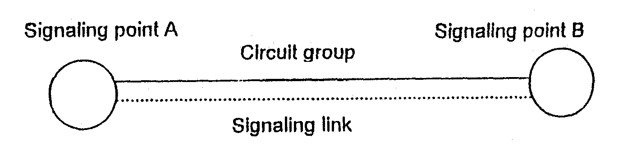
Fig. 1
Associated mode of signalling

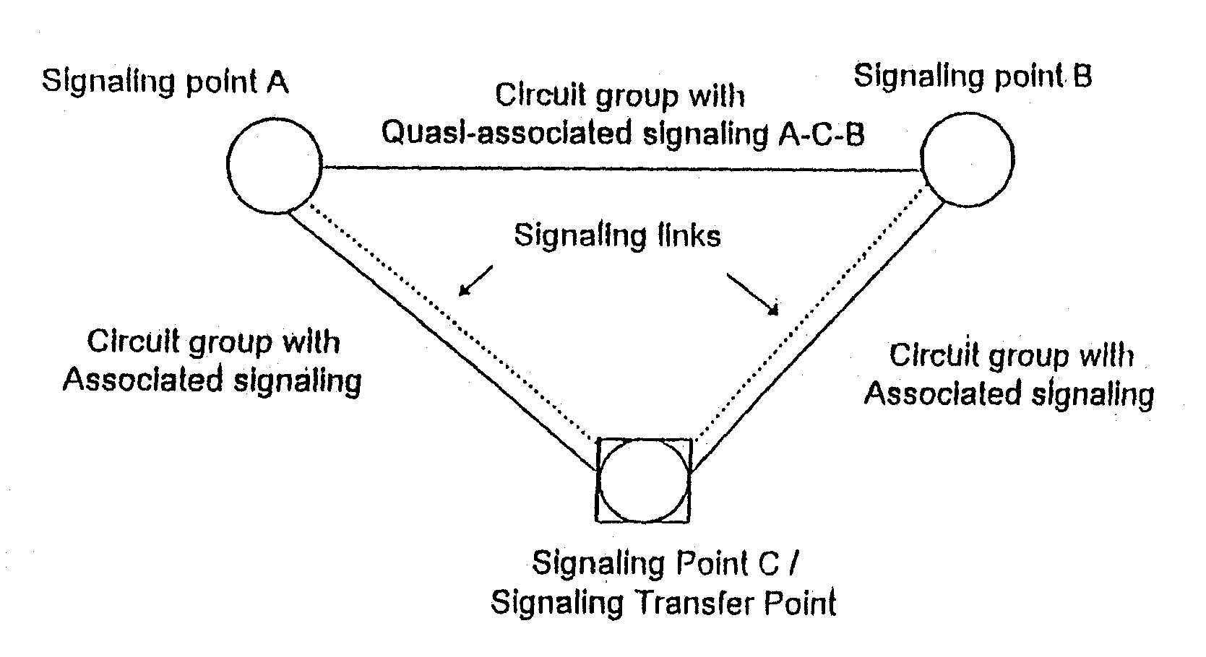
Fig. 2
Quasi-associated mode of signalling
An important field in the ISDN-UP message is the routing label comprising of the DPC, the OPC and the SLS field as shown in Fig.3. The Circuit Identification Code (CIC) assigns the message to a specific circuit, while OPC and DPC are the Point Codes for the origination and destination exchanges. A CIC is permanently assigned to each circuit.
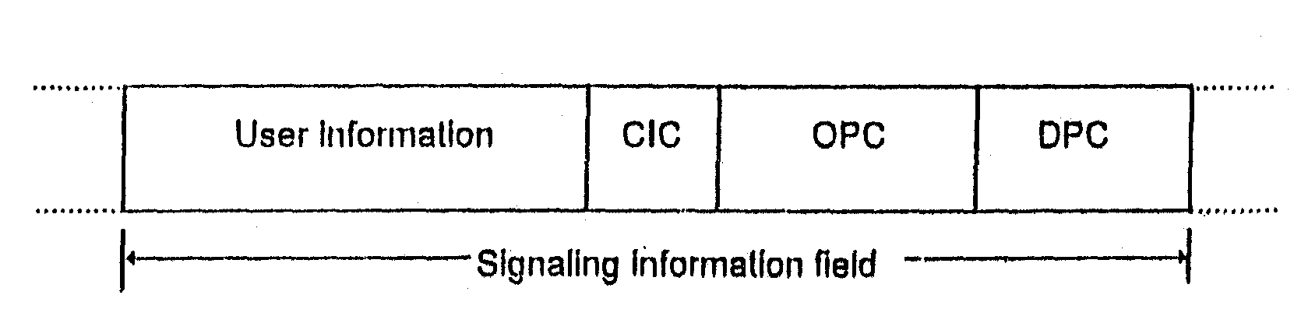
Fig. 3
Routing Label of a Message Signal Unit.
2. Common Channel Signalling Network Control (CCNC)
The CCNC is a multi-microprocessor control system which can both control digital and analog signalling links. The function of the CCNC is to handle and ensure the exchange of messages between the exchanges. The CCNC can be used in exchanges that function as signalling points (SP) or signalling transfer points (STP).
The CCNC is connected to the coordination processor (CP) in a similar manner to a message buffer unit (MBU). The communication between the CCNC and the CP or line/trunk groups (LTG) is handled by an input/output processor for message buffer (IOP:MB) in the CP. The position of CCNC is shown in Fig.4.

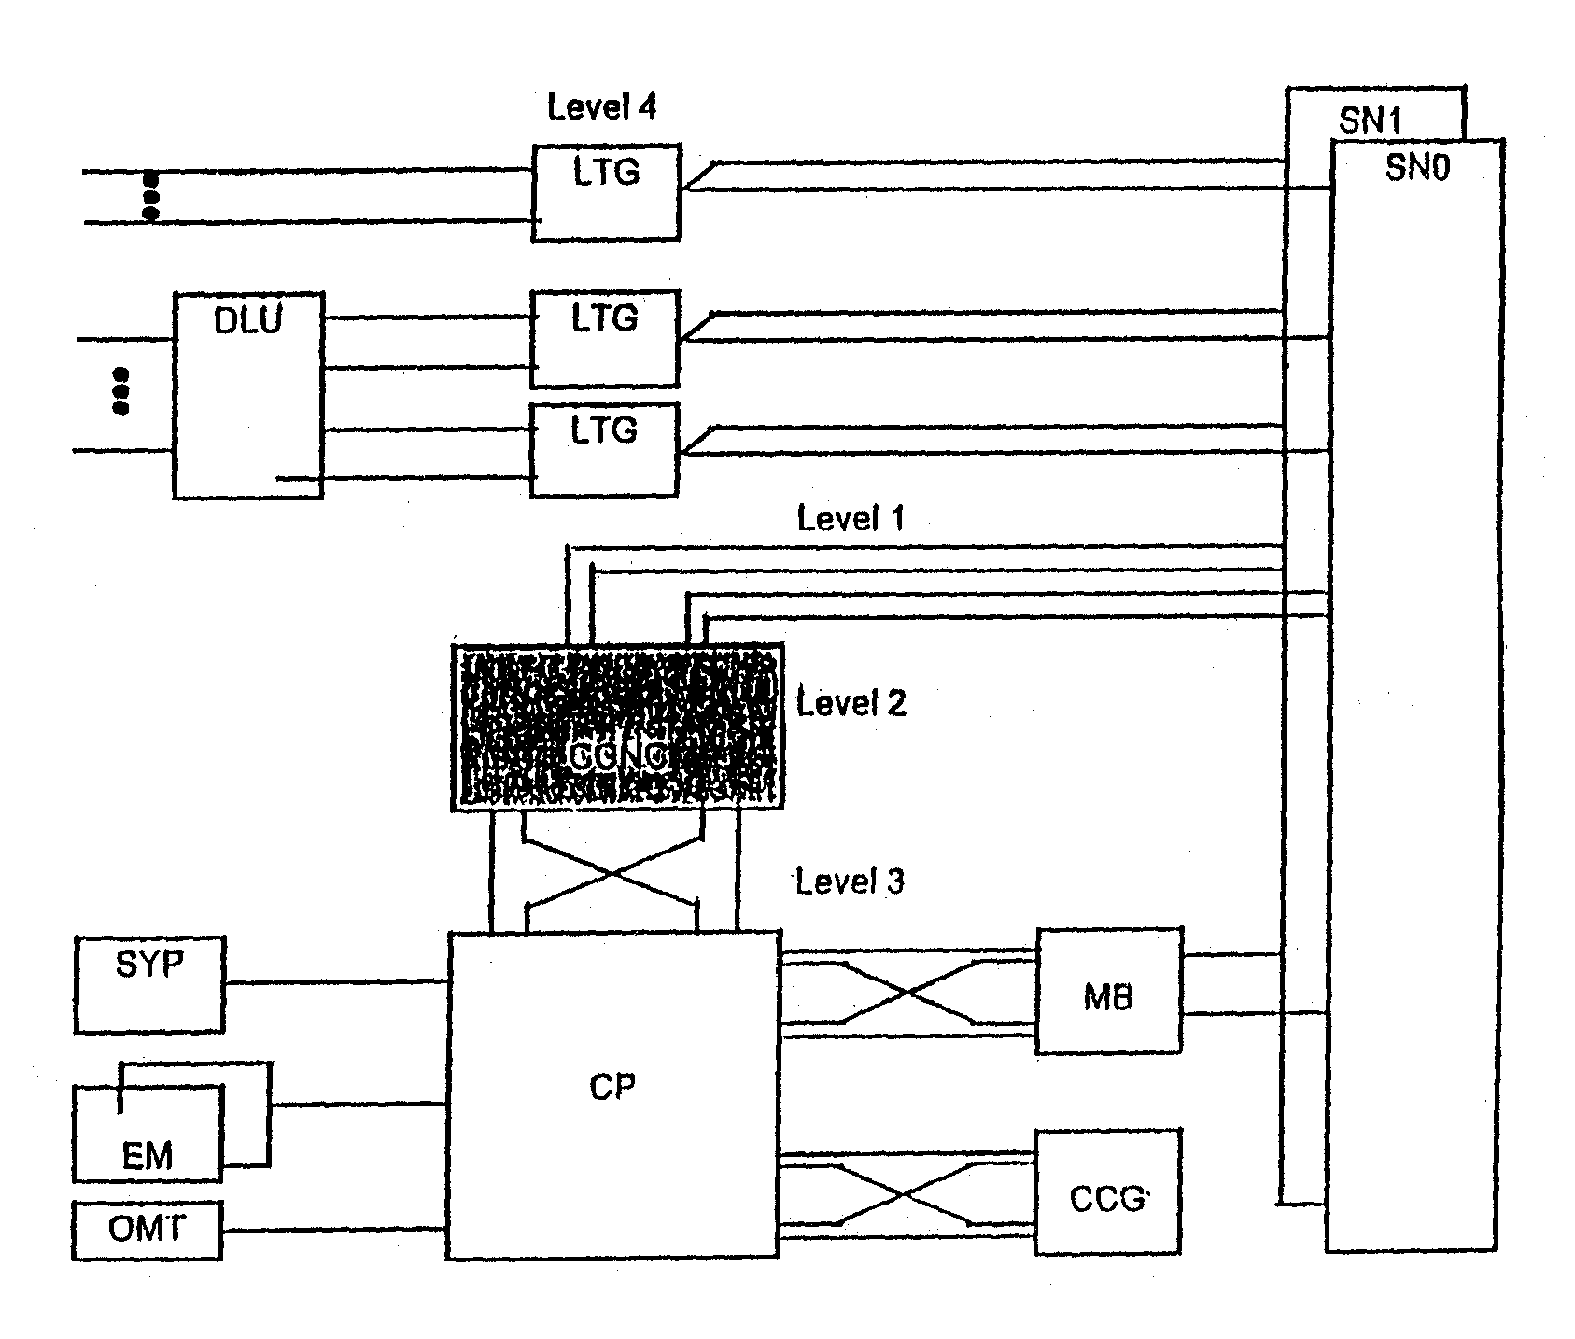

Fig. 4
Position of the CCNC in EWSD

The functions of the UP (level 4) are located in the LTG, and the functions of the MTP (level 1, 2 and 3) are integrated in the CCNC. In addition to the MTP functions, the CCNC also processes maintenance and administration task (as shown in Fig.5).

Fig. 5
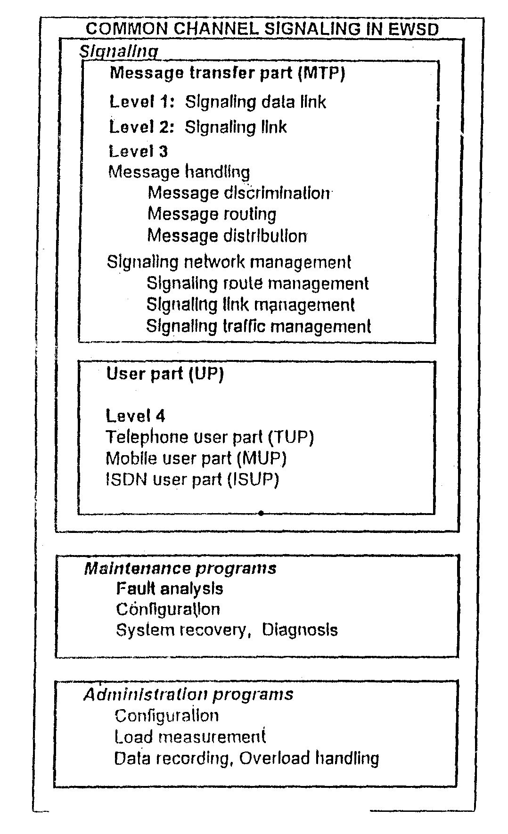
Functions of common channel signalling system no.7 in EWSD
3. CCNC Structure
The CCNC can be subdivided into the following three functional areas as shown in Fig.6.
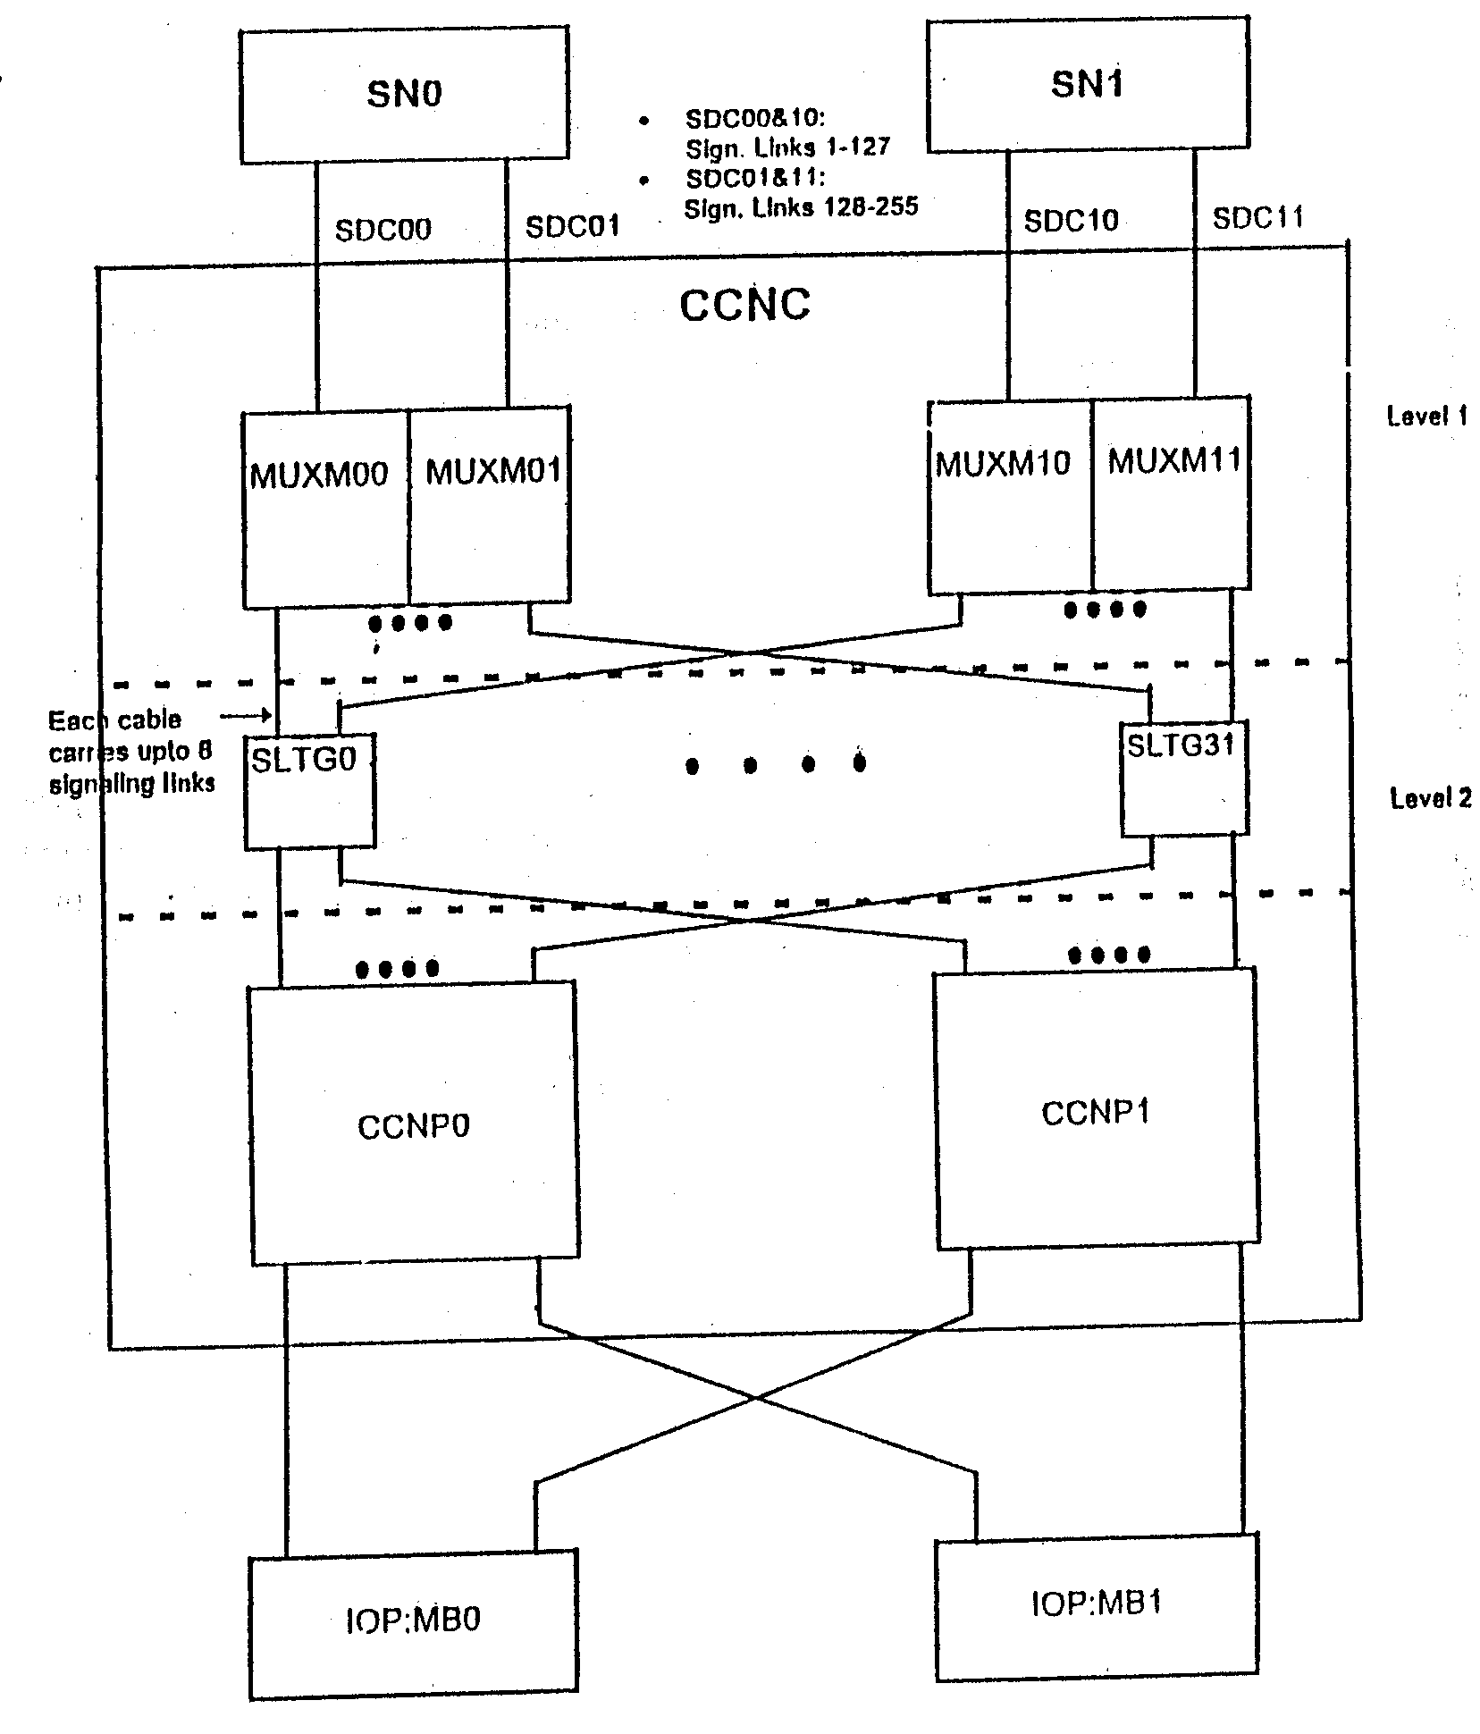
Fig. 6
CCNC Functional Areas

Multiplexer (MUX)
The main function of the multiplexers is the handling of the level 1 functions for up to 254 digital signalling links.
The common channel signalling links are routed between two exchanges via multiplex lines. The signalling links are extended to the multiplexer system (MUXM/MUXS) via the line/trunk groups (LTG) using semi-permanent connections in the switching network (SN) as shown in Fig.4.
Signalling Line Terminal Group (SILTG)
Each set of eight SILTDs (Signalling Line Terminal Digital) is combined into a group (SILTG) with one SILTC (Signalling Line Terminal Control). An SILTD is permanently assigned to a signalling link. An SILTD represents the end of a signalling link. The functions of CCS7 level 2 (message securing functions) are implemented in the SILTD.
Common Channel Signalling Network Processor (CCNP)
It consists of Signalling Periphery Adapter (SIPA) Signalling Management Processor (SIMP) and Coordination Processor Interface (CPI). The functions of CCS7 level 3 (message transfer functions) are implemented in SIMP. This includes signalling message handling, message discrimination, message distribution and CCS7 network management.
4. Functions
The functions performed by a CCNC are dependent on :
- whether the signalling information of the message signal unit (MSU) is sent from or to be received by a line/trunk group (LTG) or the coordination processor (CP) of the same exchange (signalling point (SP) function) or
- whether the MSU is to be through-connected between two other exchanges (signalling transfer point (STP) function).
4.1 Signalling Point Function
Figure 7 indicates as an example of the signalling point (SP) function, the through-connection of the signalling information of message signal unit (MSU) via the CCNC to the user. The CCNC extends the incoming signalling information received from the common signalling channel of a multiplex line to a group processor (GP) of the appropriate LTG in the same exchange.

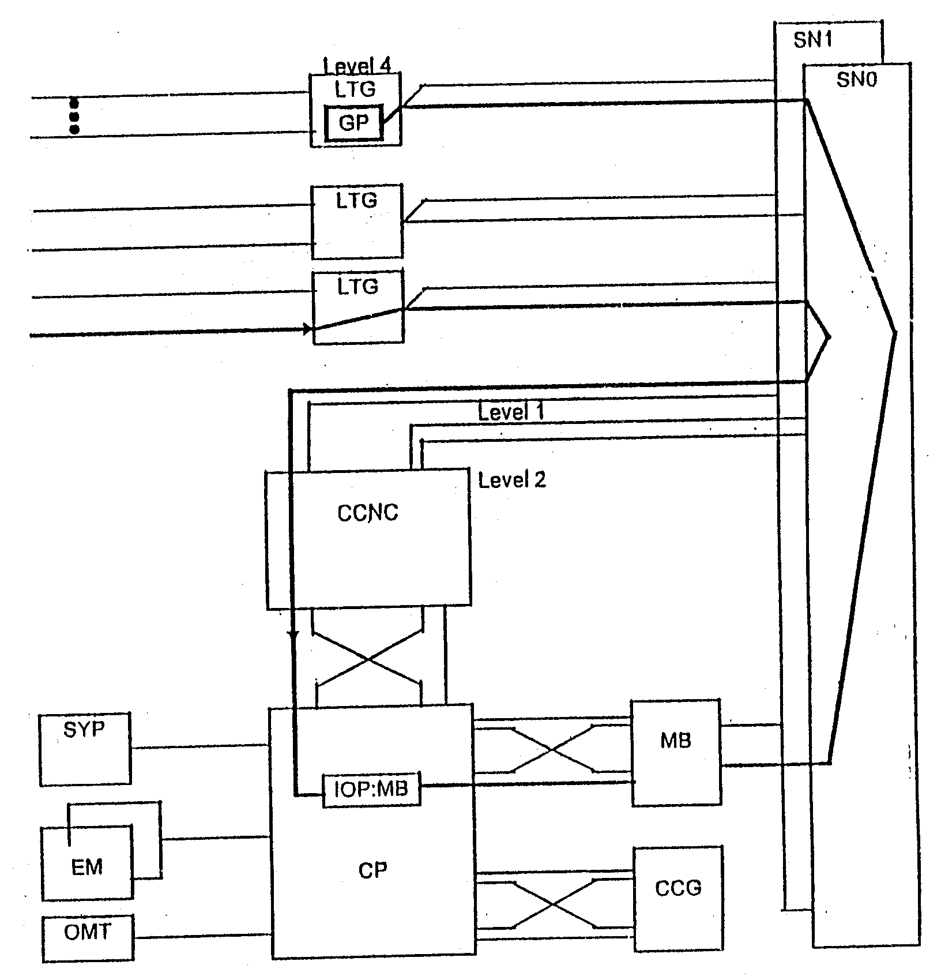

Fig. 7
Signalling point function

Through connection of signalling information of message signal unit (MSU) by the CCNC to user (LTG) in the same exchange
The incoming CCS7 information is transparently through-connected in the switching network (SN) via a semi-permanent (nailed-up) connection (NUC) to the CCNC. The CCNC determines the user (LTG-No.) of the MSU and then forwards the signalling information to the input/output processor for message buffer (IOP:MB) in the CP. The signalling information is then extended via the message buffer (MB) and via the SN in the appropriate message channel to GP in the LTG.
4.2 Signalling Transfer Point Function
The signalling transfer point (STP) function performed by a CCNC during the through-connection of CCS7 information between other exchanges is indicated in Fig.8. In this case, the received CCS7 information (MSU) does not have to be processed in the exchange and is transparently transferred to the destination exchange. The CCNC recognizes that the received CCS7 information (MSU) is not destined for a user in the exchange. The CCNC extends the CCS7 information via a semi-permanent connection (NUC) in the SN to the common signalling channel of a multiplex line routed to the destination exchange. This type of signalling via an intermediate exchange functioning as an STP and not directly between the two exchanges directly concerned is referred to as quasi-associated signalling.

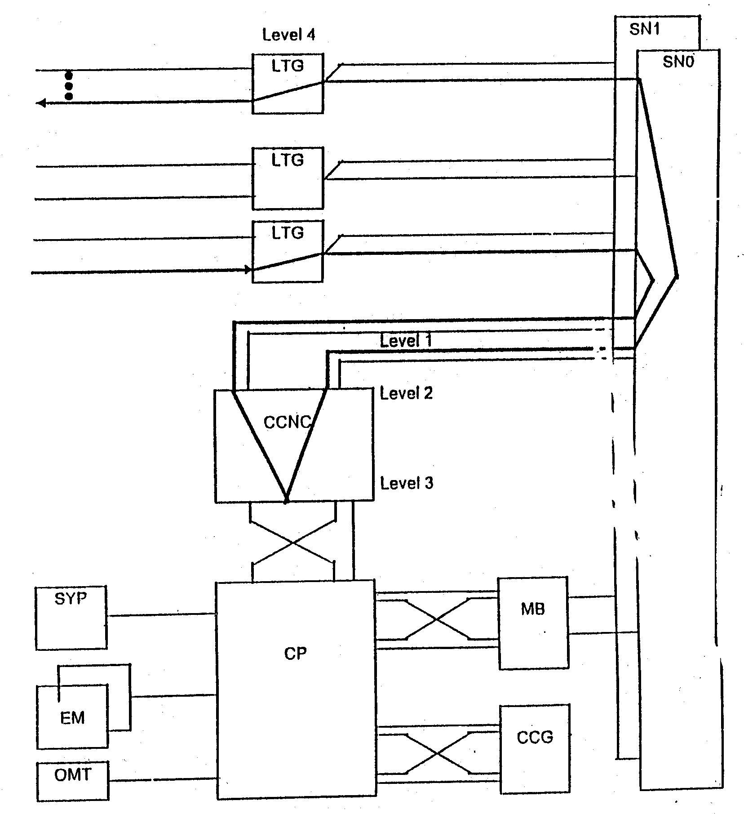

Fig. 8
Signalling transfer point function

Receipt of message signal unit (MSU) from another exchange and transmission of the same MSU to yet another exchange

